**Topics: Confidence Intervals**

1. For each of the following statements, indicate whether it is True/False. If false, explain why.
2. The sample size of the survey should at least be a fixed percentage of the population size in order to produce representative results.

A: False, because there is no fixed percentage population for sampling.

1. The sampling frame is a list of every item that appears in a survey sample, including those that did not respond to questions.

A: False, because the sampling frame is a list or set of items from which a sample is drawn. It should ideally include all the elements of the target population that the researchers want to study. The key point is that the sampling frame should represent the population of interest from which the sample is selected.

1. Larger surveys convey a more accurate impression of the population than smaller surveys.

A: True, Because Larger surveys generally improve the accuracy of estimates compared to smaller surveys by reducing sampling error and increasing precision.

However, the validity of any survey relies heavily on representative sampling, proper methodology, and careful control of biases. There's always a balance between accuracy, cost, and practicality when deciding on the optimal sample size.

1. *PC Magazine* asked all of its readers to participate in a survey of their satisfaction with different brands of electronics. In the 2004 survey, which was included in an issue of the magazine that year, more than 9000 readers rated the products on a scale from 1 to 10. The magazine reported that the average rating assigned by 225 readers to a Kodak compact digital camera was 7.5. For this product, identify the following:
2. The population.

225/9000 = 0.025

1. The parameter of interest.

Average, Size and Scale

1. The sampling Frame.

9000

1. The sample size.

225

1. The sampling Design.

0-10

1. Any potential sources of bias or other problems with the survey or sample.

Bias

1. For each of the following statements, indicate whether it is True/False. If false, explain why.
2. If the 95% confidence interval for the average purchase of customers at a department store is $50 to $110, then $100 is a plausible value for the population mean at this level of confidence.

A: True, because 95% confidence interval of $50 to $110 indicates that we are reasonably confident that the true average purchase amount of customers lies somewhere between these values, and $100 is a plausible value within this range.

1. If the 95% confidence interval for the number of moviegoers who purchase concessions is 30% to 45%, this means that fewer than half of all Moviegoers purchase concessions.

A: False, because Majority buying concessions: The true population proportion could be slightly above 50%, falling within the interval.Minority buying concessions: The true proportion could be below 50%, also fitting within the interval.Proportion around 50%: The true proportion could be very close to 50%, making it difficult to conclusively state whether it's above or below without a narrower interval.

1. The 95% Confidence-Interval for *μ* only applies if the sample data are nearly normally distributed.

A: True, Because When the sample data are nearly normally distributed, the t-distribution closely resembles the standard normal distribution (z-distribution) used when the population standard deviation (σ) is known.

This allows us to use the t-distribution table or calculations with the appropriate degrees of freedom (df) to obtain the critical t-value for constructing the confidence interval.

If the sample data are not nearly normally distributed, the t-distribution might deviate significantly from the normal distribution, leading to inaccurate confidence intervals.

1. What are the chances that 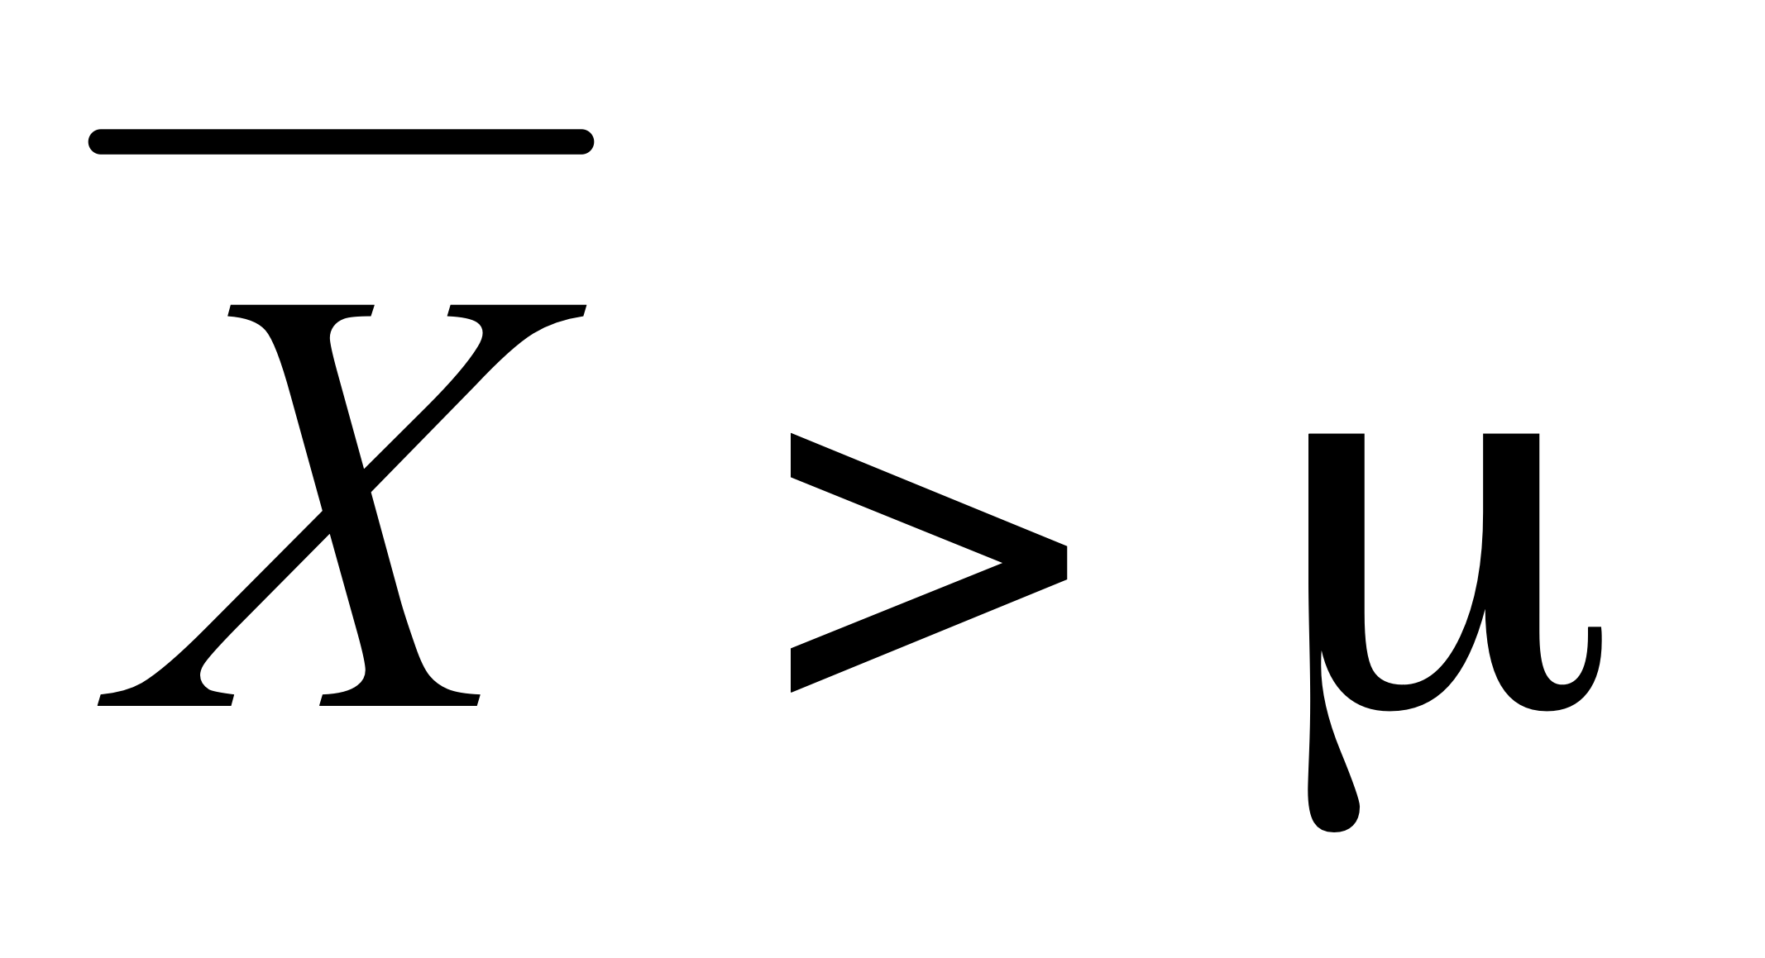?
2. ¼
3. ½
4. ¾
5. 1

A: B

1. In January 2005, a company that monitors Internet traffic (WebSideStory) reported that its sampling revealed that the Mozilla Firefox browser launched in 2004 had grabbed a 4.6% share of the market.
2. If the sample were based on 2,000 users, could Microsoft conclude that Mozilla has a less than 5% share of the market?

A: p =4.6%

n=2000

t- Statistics=0.821

z-score critical value= -1.96 (left tail skewed)

hence we conclude that t>z. so Mozilla has a less than 5% shares.

1. WebSideStory claims that its sample includes all the daily Internet users. If that’s the case, then can Microsoft conclude that Mozilla has a less than 5% share of the market?

A: Mozilla has less than 5% shares because 4.6% is mean sample of shares.

1. A book publisher monitors the size of shipments of its textbooks to university bookstores. For a sample of texts used at various schools, the 95% confidence interval for the size of the shipment was 250 ± 45 books. Which, if any, of the following interpretations of this interval are correct?
2. All shipments are between 205 and 295 books.
3. 95% of shipments are between 205 and 295 books.
4. The procedure that produced this interval generates ranges that hold the population mean for 95% of samples.
5. If we get another sample, then we can be 95% sure that the mean of this second sample is between 205 and 295.
6. We can be 95% confident that the range 160 to 340 holds the population mean.

A:[ C ] The procedure that produced this interval generates ranges that hold the population mean for 95% of samples.

1. Which is shorter: a 95% *z*-interval or a 95% *t*-interval for *μ* if we know that σ =s?
2. The z-interval is shorter
3. The t-interval is shorter
4. Both are equal
5. We cannot say

A: [ A ] The z-interval is shorter - Because ,The t-distribution has wider tails than the standard normal distribution to account for the uncertainty introduced by substituting the sample standard deviation for the population standard deviation. This increased variability results in wider confidence intervals. When you know σ, you eliminate that extra source of uncertainty, resulting in a narrower confidence interval.

Questions 8 and 9 are based on the following: To prepare a report on the economy, analysts need to estimate the percentage of businesses that plan to hire additional employees in the next 60 days.

1. How many randomly selected employers (minimum number) must we contact in order to guarantee a margin of error of no more than 4% (at 95% confidence)?
2. 600
3. 400
4. 550
5. 1000

A: for a confidence level, the z-score is approximately 1.96.you can find this using a standard normal distribution

We use p = 0.5 to maximize the required sample size,giving us the most conservative estimate

Margin error of no more than 4% so E = 0.04

n = (1.96^2 * 0.5 * (1-0.5)) / 0.04^2

n = 600.25

[A]

1. Suppose we want the above margin of error to be based on a 98% confidence level. What sample size (minimum) must we now use?
2. 1000
3. 757
4. 848
5. 543

A: [ C ] for a confidence level, the z-score is approximately 2.33.you can find this using a standard normal distribution

We use p = 0.5 to maximize the required sample size,giving us the most conservative estimate

Margin error of no more than 4% so E = 0.04

n = (2.33^2 * 0.5 * (1-0.5)) / 0.04^2

n = 847.4